Situation Report No. 3
Flooding in Thailand - Emergency Response & Early Recovery
Date of Report: 4 November 2011

CONTEXT

Since July, flooding in Thailand has affected 9.5 million people (2.1 million of which are still acutely affected); 437 people have died primarily due to drowning and electrocution.
Thailand’s most severe floods in half a century peaked over the weekend of 28 October but fortunately, the barriers surrounding the central business district of the country’s capital, Bangkok, withstood floodwaters of record-heights (over 7.5 ft or 2.53 m), a result of monsoon runoff from northern areas and monthly tidal surges of the Chao Praya River. Of the 50 districts in the Bangkok province, only seven were heavily affected and many tourist attractions were spared destruction/damage. Since the flooding started on 5 July 63 provinces have been affected out of a total of 77, in 38 the water has receded and restoration work has begun. A total of 70 highways in 13 provinces and 223 rural roads in 30 provinces remain impassable.
In the greater Bangkok area local surveys report increasing stress levels among flood-affected people, commonly due to lost income/livelihoods. Likewise, frustration with lack of drainage led residents in several communities to destroy dikes in order to release the water impeding their access to homes and stores. For example on 29 October, a group of residents destroyed a dyke near Wat Nawong in Don Muang, causing a huge volume of floodwater to flow into the which supplies tap water to Bangkok. The Military has deployed 50,000 troops across the country to guard and maintain the flood barriers.
In Bangkok, 15 districts out of 50 remain inundated although the inner city escaped the severe flooding predicted over the last four days. Bangkok’s Flood Relief Operations Centre (FROC) has relocated to the Chatuchak area as Don Muang Airport is now completely flooded and electricity is cut off.

In areas where floodwaters have receded, clean-up and recovery activities are underway with strong participation by local actors - volunteers, government and Army. Distributions of emergency food and water are proceeding in an orderly fashion. With the next high tides not expected until mid-November, the Government is now focusing on expediting the process to divert northern run-off into the sea mostly through the western part of the city.

The situation in the central region has improved as runoff water gradually subsides. Access to the north is also improving with both the rail line and highway between Bangkok and the northern city of Chiang Mai reopened after a month of interruption.

A convergence of high tides and runoff from the north arrived in Thailand’s capital, Bangkok, over the weekend of 28 October inundating many suburban districts and areas along the Chao Phraya River. The city centre remains unaffected as the barriers held off the high tides on 28 October. However, the situation in seven flooded districts in the northern and western parts of the city remains critical with water levels rising above one metre in certain areas.

The situation in the outer city remains dire as run-off water continues to inundate suburban areas. The Government says flood waters in all parts of Bangkok will remain for a few weeks before draining into the Gulf of Thailand.

As the flood water recedes in some provinces, recovery plans are now underway. The Government has announced a short and long term flood reconstruction plan, called the New Thailand scheme, which is expected to cost 800 billion baht (US$ 26 billion).
The UN reaffirms that it stands ready to support the Government efforts to formulate a long-term response to the crisis, beyond the present emergency situation. The UN (ESCAP) is also supporting FROC with access to satellite imagery capturing flood wave dynamics for improved monitoring of the floods.

HUMANITARIAN SITUATION IN THAILAND

- 9.94 million people have been affected (2.1 million of which are still acutely affected);
- 437 people have died primarily due to drowning and electrocution.
- An estimated 25% of Thailand’s rice crop (4 million acres, the size of Kuwait), has been destroyed.
- Industrial Areas have been flooded and stopped production in dozens of factories, leaving up to one million people unemployed.
- While markets in some of the affected communities are functioning, the Government of Thailand (GoT) has begun enforcing price controls on essential items to reduce hording and profiteering.
- The GoT has instituted a compensation scheme for people whose homes/assets were damaged.
- Thailand is forced to import essential goods such as drinking water and eggs
- 1,700 evacuation centers have been established to accommodate up to 800,000 people; however, these are filled only at 14% capacity as most people in affected areas chose to stay in their homes, out of concern for their property.
- The vulnerability of Migrants has increased (legal status, lack of employment, psychological uncertainities)

CARITAS THAILAND RESPONSE

- Formation of the ‘Emergency Response Committee (ERC) to be responsible for the overall management and coordination of the response).
- Invitation to Catholic Relief Services (CRS) to facilitate the ERC by providing expertise in emergency management, WASH & general support.
- So far the work of the ERC has been: that the lead will be taken by the Diocesan Social Action Centers (DISACs) at Nakhon Sawan and Bangkok through the coordination by national Caritas Thailand and responsible desks; Catholic Office for Emergency Relief and Refugees (COERR) and National Catholic Commission on Migration (NCCM), according to its structure.
- The designation of key roles and responsibilities together with the personnel for Emergency Relief and Early Recovery including Distribution, WASH, Livelihood, and Health have been identified.
- Launching of Flood Response Appeal ‘Emergency & Early Recovery Phase’ to the Caritas Confederation was made by Caritas Internationalis on October 29, 2011.
- Appeals for support to other partner organizations.
- Appeals and acceptance of support from within Thailand.
- Media coverage such as the use of local church newspaper, TV and radio channels as well as an introduction of www.facebook.com/THAIcatholics.Floods for people participation, all of these have been operated with the close coordination and collaboration with Catholic Social Communications of Thailand and Social Commissions in all dioceses.
Support/Assistance Provided by Caritas Thailand (from August to November 2, 2011):

Support/Assistance Provided | Number
Food and non-food items/supplies;  Food item; rice, Instant noodles, canned fish, other food items, medicines, drinking water, etc.  Non-food; flashlights, sanitary napkins, tissues, soaps, shampoo, mosquito repellent, etc. | Over 11,000 families in 13 provinces through collaboration with Diocesan Social Action Centers (DISACs) and volunteers in different dioceses.  Note: this number does not cover those being supported by own funds of DISACs or others.
Mobile medical services | To flood affected areas in 2 Sub-districts of Bangkok’s Lat Krabang District (mostly Muslim communities). This happened with coordination with Catholic Medical provider Association of Thailand (from Ratchaburi Diocese) together with Camillian Task Force. 240 People have been treated directly by 2 mobile medical centers.
Other supports | - 4 boats for 4 communities in Ayutthaya  - 110 Lifejackets to community volunteers in Uthaithani and Pathumthani Provinces  - 3,000 sand bags; for Ayutthaya and Bangkok  - Ready-to-eat food (sticky rice and grilled chicken) for affected people during our visits.

Target Groups for Support/Assistance:
- Vulnerable Thai affected by the Flooding
- Migrants affected by the Flooding

Priority Groups for Support/Assistance:
- Those not in receipt of government assistance
- Those not in receipt of assistance from other NGO’s
- Poor Families/households
- Infants
- Children
- Sick
- Aged
- Nursing mothers

Target Areas for Support/Assistance:
- Archdiocese of Bangkok
- Diocese of Nakhon Sawan
- Dioceses of Chiang Mai, Tharae, Udonthani, Ubon Ratchathani and Chantaburi (on early recovery)

Donation Update/Pledges received:

Caritas Member Organizations | Amount – EUR | Remarks
Caritas Thailand | 73,000 | Contribution from local fundraising
Caritas Germany | 40,000
CRS | 143,000
Total | 256,000 | 44% of CI Appeal of 576,000 Euros

Note:
Apart from this, Caritas Thailand is in communication with Caritas Australia, Trocaire, Caritas Corea, Caritas Hong Kong, CHARIS of Singapore and MISEREOR (with specific proposal).

Coordination with othe organizations:

Caritas Thailand has been in coordination with organizations on the response as follows;

  - Catholic Relief Services (CRS); Specific expertices; emergency response management, WASH and Livelihood.
  - Caritas Asia; Communication
  - Save the Children; Emergency response and coordination
  - Camillian Task Force; Mobile medical services
  - Catholic Medical Provider Association of Thailand; Providing volunteering doctors and nurses
  - Religious Congregations; Sisters of Sacred Heart of Jesus, Sisters of St. Paul De Chartre, Sisters of St. Josep of Apparition, etc.

Stories:

- Caritas launches appeal for Thailand’s flood survivors

In the wake of floods that submerged homes, crops, factories and more, Caritas Internationalis is calling for EUR 506,494 to help the people of Thailand.

This year’s strikingly heavy monsoon rain led to flooding in the majority of Thailand’s provinces, affecting over 8 million people. Caritas Thailand immediately responded to the crisis by distributing food, soap, and other essentials to thousands of families through diocesan partners.

Read more:
http://caritas.org/newsroom/press_releases/PressRelease02_11_11.html

- Monks, punks and priests help Thailand after floods

...The distribution itself is very ceremonial. As we enter the temple a large open plan building with high pillars and mats on the floor, there are maybe 2000 people sitting patiently and neatly, cross-legged. ...an elderly, wizened, saffron-clad monk observes in the background.

Simultaneously, 50 volunteers in pink vests (from the Lions Club of Phrae) are unloading the food packages into tidy piles. The volunteers are a mixed bunch of civic workers and young people, even a punk, all compelled to help their countrymen. ...

Read more:
http://blog.caritas.org/2011/11/03/monks-punks-and-priests-help-thailand-after-floods/

- Photos
Photos of Caritas’ flood relief work in Thailand: http://flickr.com/gp/27673812@N05/Yf971j/

Contact information:
Bishop Pibul Visitnondachai: +6681 646 7184 Email: fr.pibul@coerr.org
Rev. Fr. Pairat Sriprasert: +6681 869 4514 Email: fr.pairat@caritasthailand.net
Mr. Jirawat Chenpasuk: +6689 148 4549 Email: jirawat@caritasthailand.net
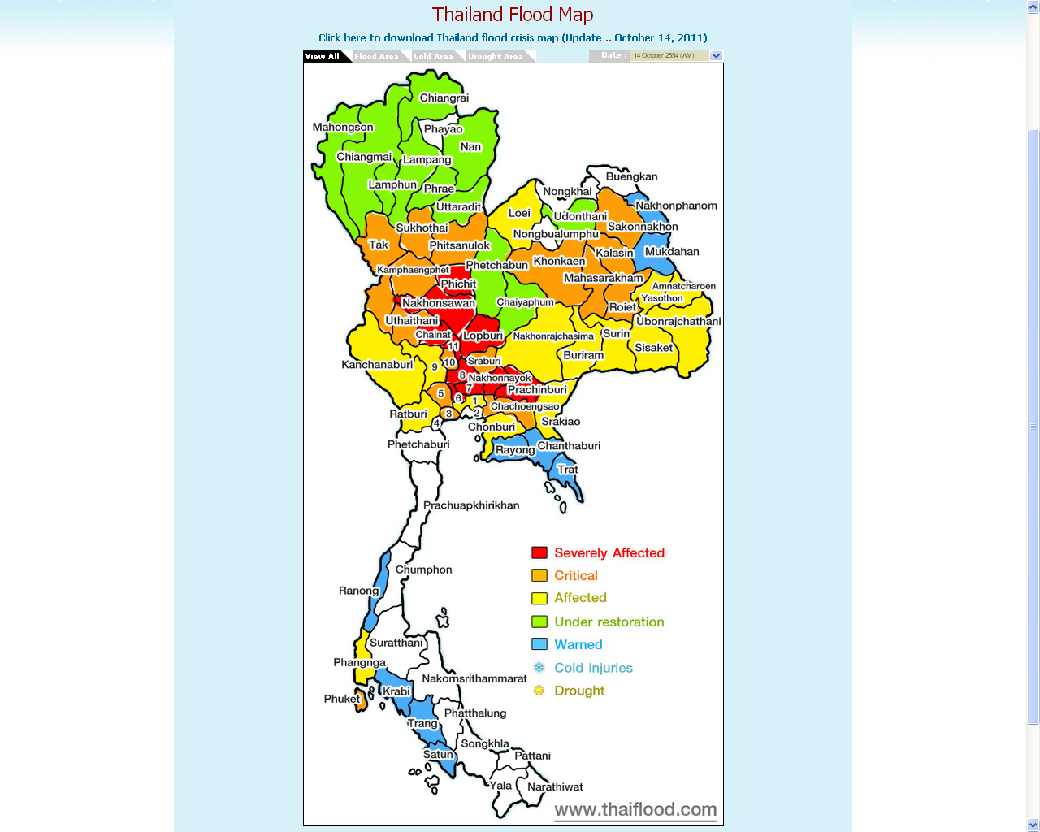
Legends
- Bangkok
- Samut Prakan
- Samut Sakhon
- Samut Songkhram
- Nakhon Pathom
- Nontaburi
- Pathum Thani
- Ayuthaya
- Suphanburi
- Ang Thong
- Sing Buri

Source: http://www.thaiflood.com/en/

